COVID-19 SAFE WORK POLICIES

Covid-19 can be transmitted by:
• Breathing in droplets in the air that are generated when people cough or sneeze.
• Close contact with other people (e.g. shaking hands or hugging)
• Touching contaminated surfaces and then touching the face, mouth, or food
• Touching a contaminated surface then touching another surface may cause the virus to transfer from
Surface to another.

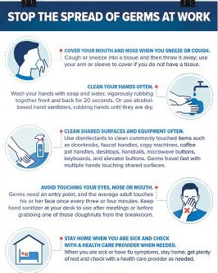
If you are sick stay home
• Anyone with COVID-19 like symptoms such as sore throat, fever, sneezing, or coughing must self-isolate at home for 14 days.
• If you have been in contact with anyone with COVID-19 you must isolate at home for 14 days.
• Please contact your supervisor and report your illness or self-isolation on as soon as possible.
• Monitor your symptoms and if you have emergency warning signs (including problems breathing) go to emergency medical care immediately.

Where possible employees should maintain a distance of 2 metres (6.5 feet) apart from each other.
• Limit of 2 employees per vehicle (when possible)
• There should be no more than 50 people on a site.
• Hold site meetings in open spaces or outside when possible.
• Avoid close contact with others (e.g. shaking hands or hugging)
• Visitors need to check in with a supervisor if on job site or work yard and must maintain social distance and proper hand hygiene.

Hand hygiene and disinfection of work areas need to be done regularly through out the workday.
• Proper hand washing is one of the best ways to minimize the risk of infection, before starting work, eating, drinking, smoking and after using the bathroom.
• If hand washing station is not available please use the hand sanitizer in all company trucks (there is 2 different kinds gel and spray)
• The spray sanitizer is there to sanitize trucks and tools as well as hands if needed. It is clearly labeled and available in all company trucks and work yard.
• Do your best to not touch your face, eyes, nose, or mouth with unwashed hands.
• Cover your mouth and nose with the crease of your elbow or a tissue when you sneeze or cough.

Proper hand washing
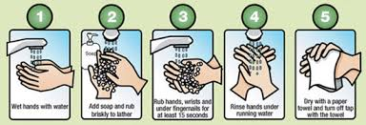

Hand sanitizer
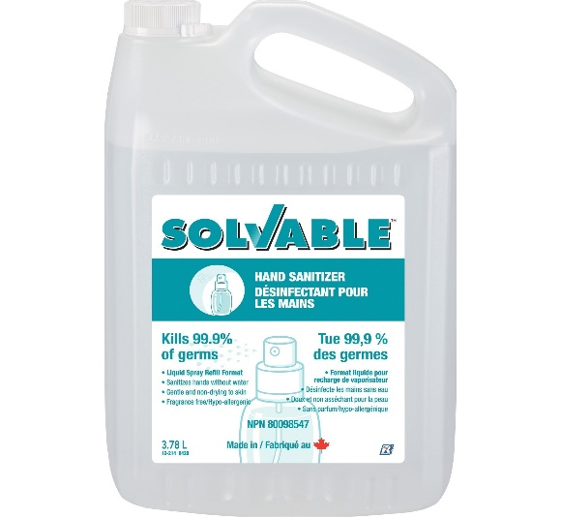
Instant hand sanitizer works without water and is hypo allergenic. Spray a small amount onto hands and massage thoroughly until dry. Also used to spray on high contact surfaces, just spray and let dry.
This product is 70% ethyl alcohol and kills 99.9% of germs.

Supervisor responsibilities:
• To make sure all employees onsite have done a symptom self assessment and if they are sick have been sent home to self isolate
•If onsite have signed hazard card for jobsite (flah)
•Help organize employees so they maintain a 2-meter social distance whenever possible
•Report and record any unsafe practises to Safety Officer

Employee responsibilities:
•To do a daily COVID-19 symptom self assessment, and if sick stay home and report your symptoms to supervisor
•Before starting work fill out and discuss Hazard card with others onsite
•Wash/sanitize your hands when needed
•Maintain 2-meter social distance whenever possible
•Sanitize trucks and equipment when required
•Report any concerns to supervisor

Company Responsibilities

Grizzly Curb & Concrete is dedicated to the health and safety of all our employees, contractors, and the public.
The coronavirus outbreak has put us all in unprecedented times. We, as a company will take all necessary precautions to minimize the risks of COVID-19 transmission and illness to our employees.

This is a constantly changing situation and will be reassessed daily and Grizzly Curb & Concrete will keep all employees updated through:
• Daily emails
• Toolbox talks
• Onsite assessments and meetings
Province website:
https//www2.gov.bc.ca/gov/content/safety/emergency-preparedness-response-recovery/covid-19-provincial-support

Joy Hubbard
Safety officer for Grizzly Curb & Concrete
250-517-7037
grizzlycurbsafety@gmail.com

